**QF600 (Asset Pricing) – Homework 3**

**Linear Factor Models**

**Performance Measurement**

Risk_Factors.xlsx contains monthly observations of the risk-free rate and the three Fama–French risk factors (expressed as percentages), over the ten-year period from Jan 2004 through Dec 2013.

Regress the monthly excess returns for each industry portfolio on the three Fama–French risk factors:

1. Create a table showing the factor loadings on SMB and HML for the ten industry portfolios.

Answer:

|  |  |  |
| --- | --- | --- |
| **Industry** | **Gamma (SMB)** | **Delta (HML)** |
| **NoDur** | -0.229102 | -0.023342 |
| **Durbl** | 0.670878 | 0.240949 |
| **Manuf** | 0.087388 | 0.027727 |
| **Enrgy** | -0.25936 | -0.008158 |
| **HiTec** | 0.335674 | -0.556947 |
| **Telcm** | -0.080299 | -0.019063 |
| **Shops** | 0.280191 | -0.03908 |
| **Hlth** | -0.212655 | -0.143765 |
| **Utils** | -0.387961 | -0.016881 |
| **Other** | -0.061676 | 0.547325 |

1. Using monthly excess returns for the ten industry portfolios, calculate the following performance metrics:

* Sharpe ratio
* Sortino ratio (using risk-free rate as target)
* Treynor ratio (using CAPM β)
* Jensen's α
* Fama–French three-factor α

The sample semi-variance can be estimated as:

where *R*i is return on industry portfolio and *R*f is risk-free rate.

1. Create a table showing the performance metrics for the ten industry portfolios.

Answer:

|  |  |  |  |  |  |
| --- | --- | --- | --- | --- | --- |
| **Industry** | **Sharpe Ratio** | **Sortino Ratio** | **Treynor Ratio** | **Jensen’s Alpha** | **Fama-French 3 Factor Alpha** |
| **NoDur** | 0.231099 | 0.350804 | 1.186372 | 0.369717 | 0.386704 |
| **Durbl** | 0.072356 | 0.111967 | 0.367463 | -0.417903 | -0.474342 |
| **Manuf** | 0.166616 | 0.24126 | 0.758251 | 0.160494 | 0.153285 |
| **Enrgy** | 0.181708 | 0.273612 | 1.14333 | 0.504485 | 0.523007 |
| **HiTec** | 0.118552 | 0.17062 | 0.564295 | -0.064024 | -0.065979 |
| **Telcm** | 0.169064 | 0.24494 | 0.836363 | 0.194348 | 0.200724 |
| **Shops** | 0.191753 | 0.293032 | 0.951258 | 0.274093 | 0.255941 |
| **Hlth** | 0.172529 | 0.270294 | 0.971435 | 0.236968 | 0.257472 |
| **Utils** | 0.210948 | 0.290044 | 1.452334 | 0.446523 | 0.474411 |
| **Other** | 0.064693 | 0.087351 | 0.299781 | -0.387508 | -0.404412 |

1. Plot your results as a bar chart for each performance metric.

Answer:

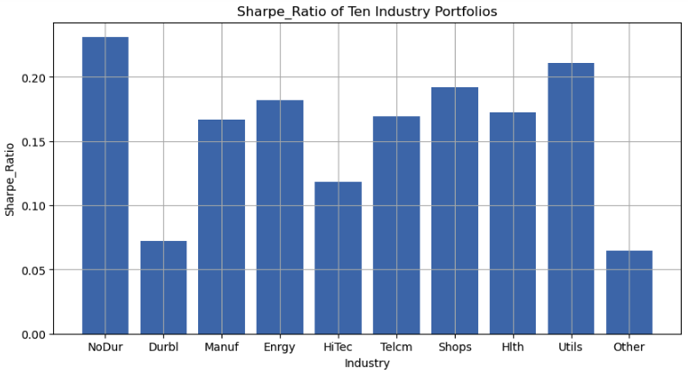

1. Briefly explain (in words, without mathematical equations or formulas) the economic significance and pricing implications of each of the three performance ratios (but not α's).

Answer:

* **Sharpe Ratio**
  + *Economic Significance:* Sharpe Ratio measures the risk premium per unit of excess return standard deviation. However, it is not ideally used to compare individual investment with diversified portfolio, as the Sharpe Ratio takes into account all risks, including systematic and idiosyncratic risk, in which diversified portfolios have no idiosyncratic risk (does not compensate diversifiable risk). The denominator also does not consider higher moments such as skewness and kurtosis and hence cannot fully reflect risk of investment if return distribution is not normal.
  + *Pricing Implication*: A high Sharpe Ratio indicates a higher expected excess return given overall risk (standard deviation), and hence is more desirable to investors. If the asset has a higher Sharpe Ratio compared to similar assets, it can be seen as underpriced relative to other assets.
* **Sortino Ratio**
  + *Economic Significance:* Sortino Ratio is the expected deviation from target return per unit of below-target semi-deviation. Unlike Sharpe ratio, the Sortino Ratio only penalizes the downside or below-target returns (denominator only counts for squared errors of negative returns and is zero for positive returns). This ratio also works for non-normal distributions (non-symmetric) and hence can be more informative than Information Ratio or Sharpe Ratio when return distribution is not normal. This ratio produces similar rankings to Information Ratio when the return distribution is symmetric, and expected asset return is close to expected target return.
  + *Pricing Implication:* A higher Sortino Ratio is more desirable to investors as it gives a higher risk premium (from target) for the same below-target risk / downside risk. If the asset has a higher Sortino Ratio compared to similar assets, it can be seen as underpriced relative to other assets.
* **Treynor Ratio**
  + *Economic Significance:* Treynor Ratio calculates the risk premium per unit of market risk (beta), risk that is inherent to market that can’t be diversified away. The denominator beta only captures systematic (market) risk and ignores idiosyncratic risk. In practice, it also fails to account for other types of systematic risk besides market risk, such as size risk and value risk. Hence, in the SML, all assets have the same Treynor Ratio. In principle, this can be used to compare performance of individual investment to diversified portfolio. The Treynor Ratio is also the slope of the SML, where all risky assets/ portfolios must have the same Treynor Ratio in equilibrium.
  + *Pricing Implication:* A higher Treynor Ratio is more desirable to investors because investment generates better return per unit of market risk. If the asset has a higher Treynor Ratio compared to similar assets, it can be seen as underpriced relative to other assets.